Hoops 4 Health (H4H) Research Survey

Do not write your name on this survey. Thank you for your participation!

Initial of first name? __________

Month of birth? __________

Initial of first name of mother or guardian? __________

Are you a boy or girl? __________

Have you participated in a Hoops 4 Health session at the Police Athletic League before (circle answer)?

Yes No

INSTRUCTIONS: Please CIRCLE the number and FILL IN the blanks for your answers.

1. Did you think about your health this past week? How many days?

0 1 2 3 4 5 6 7

If so, what do you do to take care of your health?

_____ Yes, I ___________________________________________________________

_____ No

2. How much do you know about eating healthy foods?

Not at all Somewhat A lot
1 2 3 4 5

3. How important is it to you have a healthy diet?

Not at all Somewhat A lot
1 2 3 4 5

4. How many days each week do you eat breakfast?

0 1 2 3 4 5 6 7

5. How many days each week do you eat fruit?
Do not count fruit juice.

0 1 2 3 4 5 6 7
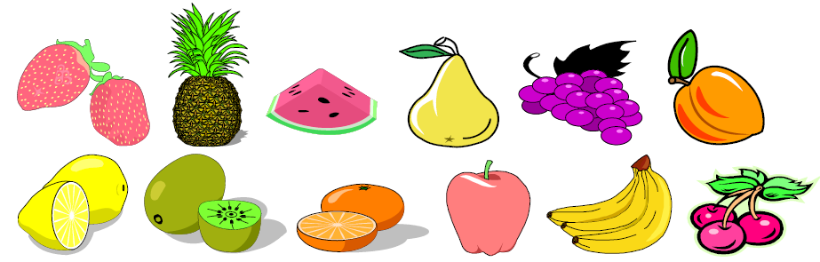

6. How many days each week do you eat vegetables?

0 1 2 3 4 5 6 7
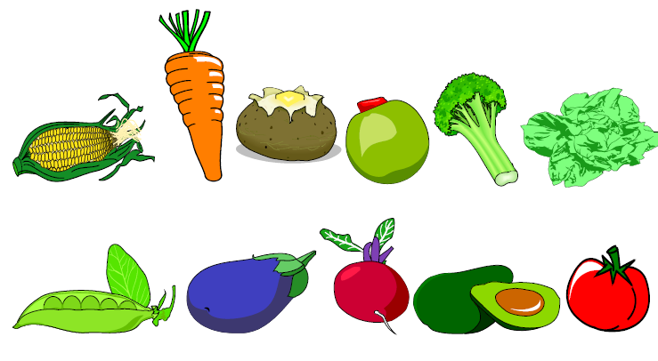

7. How many days each week do you participate in a physical activity that made your heart beat fast and made you breathe hard for at least 20 minutes? (For example: basketball, jogging, skating, fast dancing, swimming laps, tennis, fast bicycling, or aerobics?)

0 1 2 3 4 5 6 7
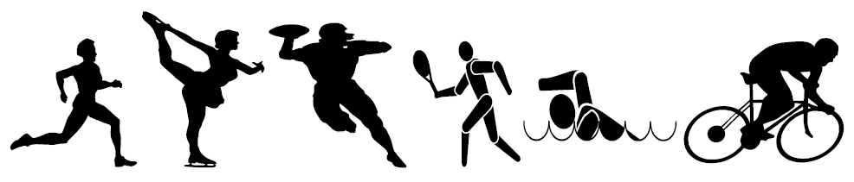

8. On the days you participate in a physical activity, how many total minutes do you play?

0-15 > 15 mins > 30 min > 1 hour > 2 hours

9. How important is it to you to stay physically active?

Not at all Somewhat A lot
1 2 3 4 5

10. How much do you like science?

Not at all Somewhat A lot
1 2 3 4 5

11. What do you think of science? I think science is …

Hard No feelings Easy
1 2 3 4 5

12. How many days in the past week did you think about science in your everyday life? (For example, why the sky is blue or how a light bulb works.)

0 1 2 3 4 5 6 7

13. What is your favorite subject in school?

Science /Math English Social Studies Arts/Music Other

14. Do you have a family member who works in science, engineering, or healthcare?

Yes No

15. What do your parents/guardians do?

________________________________ ____________________________________

16. What could someone you know (parent, family member, teacher, counselor, etc.) do or say to make you become more interested in science?

_____________________________________________________________________________

